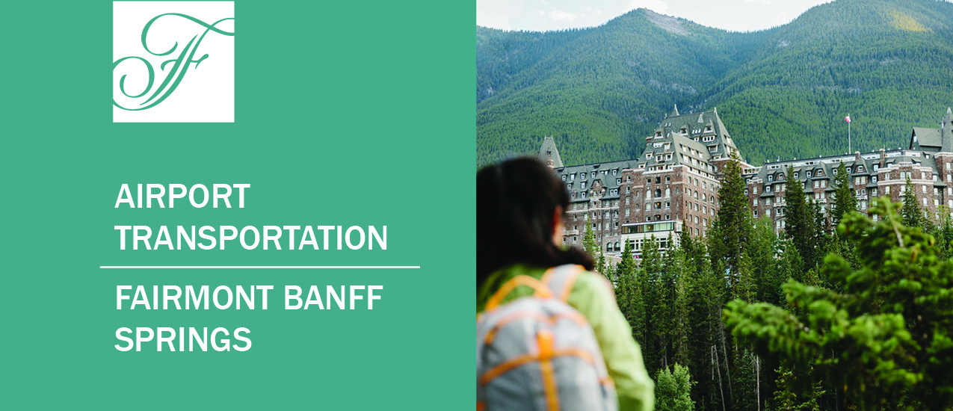

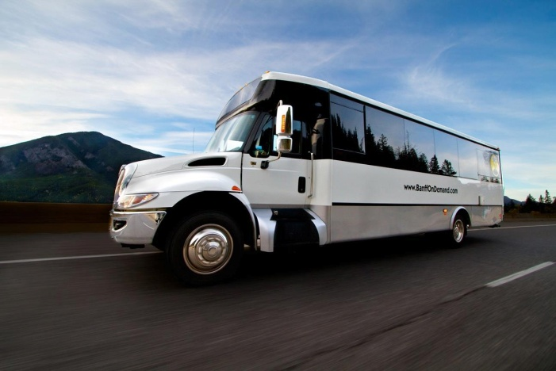
SHUTTLES
BANFF AIRPORTER SHUTTLE
Offering multiple daily transfers between Banff, Canmore and the Calgary International Airport. The Banff Airporter operates buses with separate seating and seat belts, overhead luggage storage and lighting; tissue and hand wash stations, blankets and local newspapers. Private tours and transfers are available upon request.
Departures from the Calgary International Airport to the Fairmont Banff Springs – 2 hour transfer
Departs  YYC* | 10:00 | 11:00 | 12:30 | 13:30 | 14:30 | 15:30 | 16:30 | 18:30 | 20:30 | 22:30 | 23:55
Arrives in Banff | 12:00 | 13:00 | 14:30 | 15:30 | 16:30 | 17:30 | 18:30 | 20:30 | 22:30 | 00:30 | 02:00

Departures from the Fairmont Banff Springs to the Calgary International Airport – 2 hour transfer
Departs  Banff | 2:50 | 4:50 | 6:50 | 7:50 | 9:20 | 11:20 | 12:20 | 13:20 | 15:20 | 17:20 | 19:20
Arrives at YYC | 5:00 | 7:00 | 9:00 | 10:00 | 11:30 | 13:30 | 14:30 | 15:30 | 17:30 | 19:30 | 21:30
*Calgary International Airport
Arrival times may vary due to traffic or weather. Please allow sufficient time for flight connections.
Without Insurance With Insurance
$72.44 including tax per person – one way $76.58 including tax per person – one way
$144.88 including tax per person – round trip $153.16 including tax per person – round trip
3am and 11:55pm shuttle $88.1#9 without insurance $93.23 with insurance one way
Trips are non-refundable once booked unless trip cancellation insurance is purchased at the time of booking. Prepayment is required at the time of booking with Visa or MasterCard. Passengers are allowed two pieces of luggage plus a carry-on, anything above and beyond is $10/bag. Schedule availability is subject to change during lower occupancy periods.
BREWSTER EXPRESS
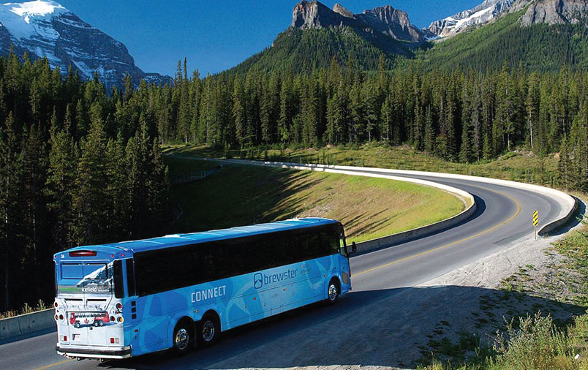
With over 125 years of experience, Brewster Express offers shuttle options between Banff, the Calgary International Airport and select Calgary downtown hotels. The Brewster Express fleet of buses provides luxury seating, large viewing windows, complimentary WiFi (where accessible) and overhead baggage compartments.
Departures from the Fairmont Banff Springs to the Calgary International Airport and downtown Calgary – 2 hour and 15 minutes to 2.5 hours transfer
Departures from the Fairmont Banff Springs to the Calgary International Airport and Calgary Downtown – (Current Schedule in effect from May 1, 2019)
Departs Banff | 6:05 | 7:35 | 9:05 | 10:35 | 12:05 | 13:35 | 15:05 | 16:35 | 18:35
Arrives at YYC | 8:30 | 10:00 | 11:30 | 13:00 | 14:30 | 16:00 | 17:30 | 19:00 | 21:45
Arrives Downtown | N/A | 10:30 | N/A | 13:30 | 15:00 | 16:30 | NA | N/A | 21:00

Departures from Calgary Downtown and Calgary International Airport to the Fairmont Banff Springs – (Current Schedule in effect from November 1, 2018 – April 30, 2019)
Departs Downtown | N/A | N/A | 11:35 | N/A | 14:35 | N/A | 17:35 | N/A | NA
Departs YYC | 9:30 | 11:00 | 12:30 | 14:00 | 15:30 | 17:00 | 18:30 | 20:00 | 22:00
Arrives in Banff | 11:30 | 13:00 | 14:30 | 16:00 | 17:30 | 19:00 | 20:30 | 22:00 | 0:00

One-way between Calgary & Banff Round-trip between Calgary & Banff
$72.45 Adult $144.90 Adult
$36.75 Child (6-15yrs) $73.50 Child (6-15yrs)
90 minute cancellation policy applies to all transfers. Service is also available to and from the Fairmont Chateau Lake Louise. Please inquire with the Concierge for further details on pricing and times.

PRIVATE VEHICLE SERVICES
ALPINE LIMOUSINE
A luxury transfer option to and from the airport. A private driver will get you to and from the mountains in a faster time and allows you the flexibility of booking the time that works for you. Private tours and transfers to different locations are available upon request.
One-way between Calgary & Banff – 1.5hrs transfer time
Premium Sedan (Mercedes S Class) 2 passengers $390.00
Executive SUV up to 5 passengers - $480.00
Executive Van 12 passengers - $690.00
SUV Stretch Limousine - 14 passengers one way - $780.00
All fares include tax and gratuity; airport pick-ups are subject to an airport fee. Payment processed 48hrs prior to the scheduled reservations. Please note that there is a 48hr cancellation policy.
*Please note an additional $50.00 will be charged for pick-ups prior to 5:00 AM and any pick-ups after 11:00 PM
BANFF SEDAN
Offering executive and group transportation between the Calgary International Airport , Banff, Canmore and Lake Louise. Enjoy exclusive coaches and professional drivers.
One-way between Calgary & Banff – 1.5hrs transfer time
Sedan; 3 passengers $400.00
Cadillac Escalade ESV 5 passengers, $490.00
Mercedes Sprinter Jet Van; 7 passengers $670.00
10 Passenger Shuttle Van; $670.00
24 Passenger Coach; $970.00
All fares include tax and gratuity; airport pick-ups are subject to an airport fee. Transfers from the Calgary International Airport are subject to the Airport fee. Payment is processed at the time of booking. Please note that there is a 48hr cancellation policy in order
TAXI SERVICE
Standard Taxi $235.00 + Airport pickup fee ($20) includes 5% tax. Gratuity is additional
Please note that there is a 24 hour cancellation policy in effect for all bookings. Larger vehicles may be available upon request. Contact Concierge for options and pricing.

